TABLE 1:
CREATE TABLE products(
id INT,
product_name VARCHAR(100),
category VARCHAR(100),
price DECIMAL(10,2),
PRIMARY KEY(id)
);
INSERT :
INSERT INTO products (id,product_name,category,price)
VALUES (1,'Laptop','Electronics',65000), (2,'Mobile','Electronics',25000),
(3,'Headphones','Accessories',3000), (4,'Smart Watch','Accessories',12000),
(5,'Keyboard','Accessories',1500), (6,'Monitor','Electronics',18000),
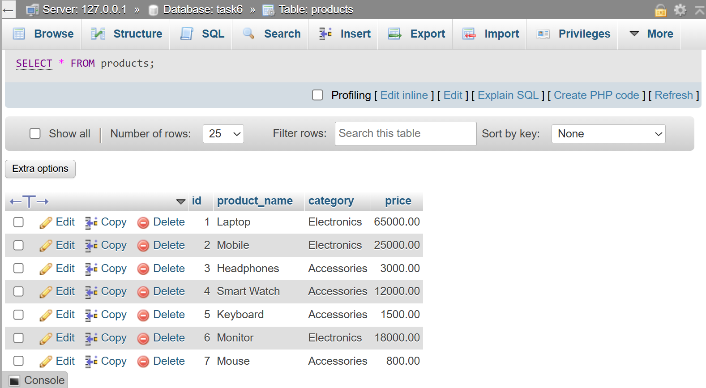
(7,'Mouse','Accessories',800);
QUESTION : 1

Write an SQL query to display all products from a 'products' table and sort them by price in ascending order, similar to how Flipkart lists items from lowest to highest price :

SELECT * FROM products
ORDER BY price ASC;
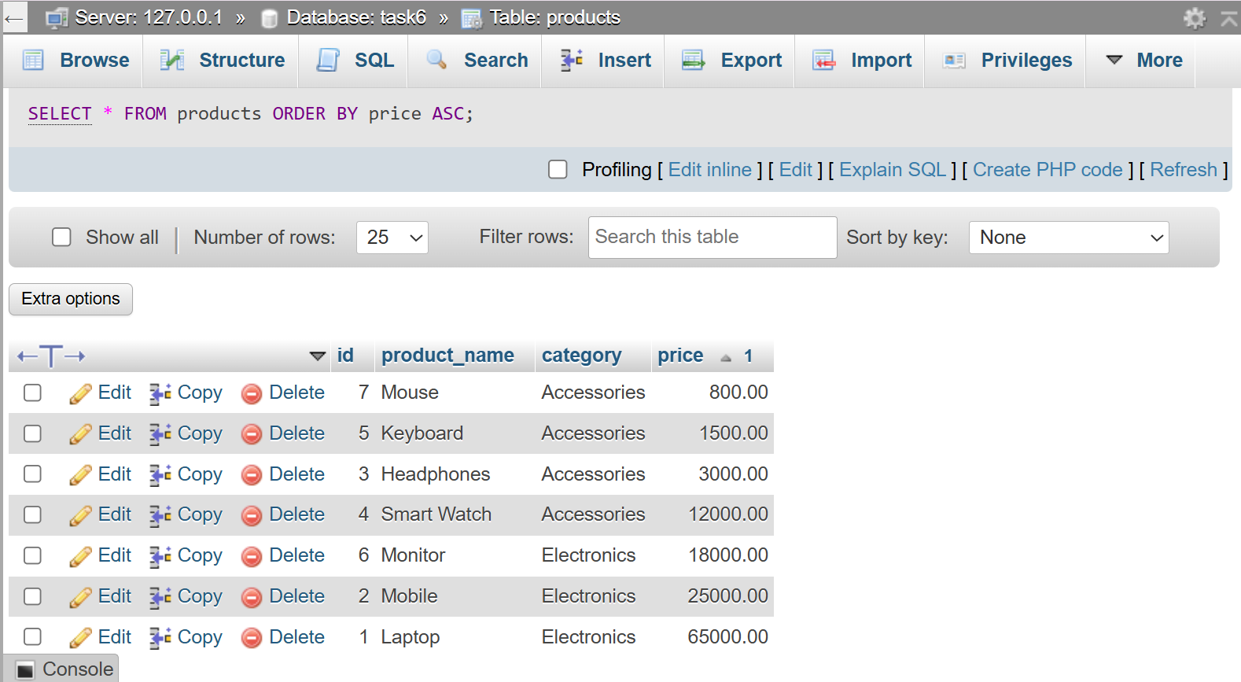

QUESTION : 2

Modify your previous query to show the top 5 most expensive products using ORDER BY with DESC and LIMIT :

SELECT * FROM products
ORDER BY price DESC
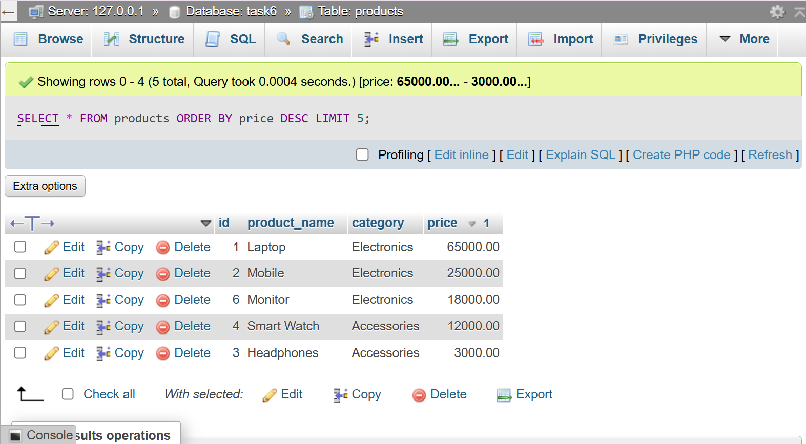
LIMIT 5;

TABLE 2:
CREATE TABLE movies(
id INT,
title VARCHAR(100),
release_year INT,
rating DECIMAL(3,1),
PRIMARY KEY(id)
);
INSERT :
INSERT INTO movies (id, title, release_year, rating)
VALUES (1,'KGF',2018,8.2), (2,'Pushpa',2021,7.9),
(3,'RRR',2022,8.5), (4,'Jawan',2023,7.8),
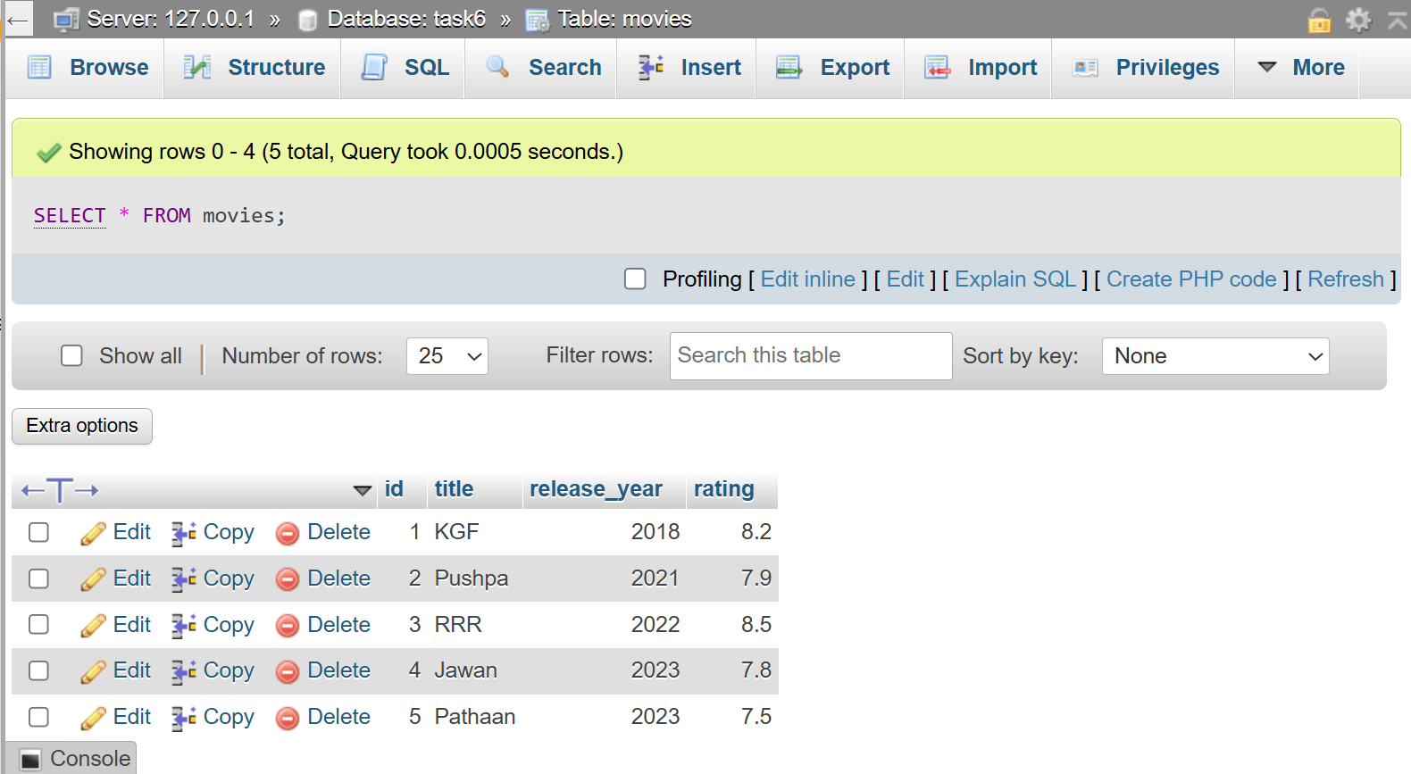
(5,'Pathaan',2023,7.5);
QUESTION : 3

Given a 'movies' table with columns 'title', 'release_year', and 'rating', write an SQL query to list all movies sorted first by release_year in descending order (latest first), then by rating in descending order (highest rated first) :

SELECT * FROM movies
ORDER BY release_year DESC, rating DESC;
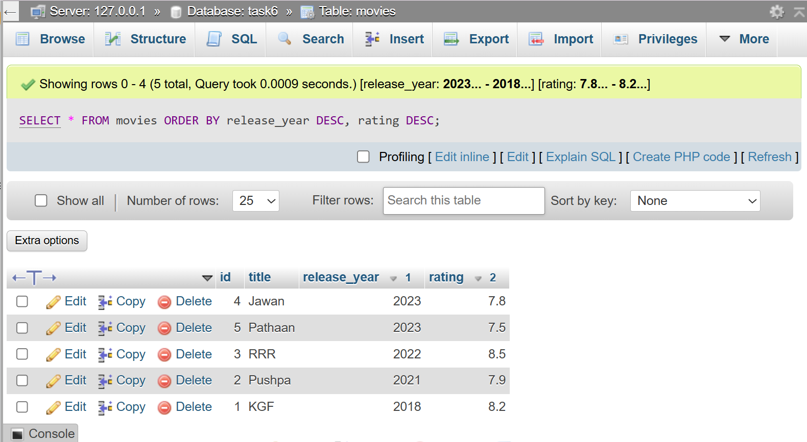

TABLE 3:
CREATE TABLE restaurants(
id INT,
name VARCHAR(100),
city VARCHAR(50),
PRIMARY KEY(id)
);
INSERT :
INSERT INTO restaurants(id,name,city)
VALUES (1,'Dominos','Ahmedabad'), (2,'Pizza hut','Surat'), (3,'Burger king','Rajkot'),
(4,'McDonalds','Ahmedabad'), (5,'Subway','Vadodara'), (6,'KFC','Surat'),
(7,'La pinoz','Ahmedabad'), (8,'Honest','Rajkot'), (9,'Gwalia','Ahmedabad'),
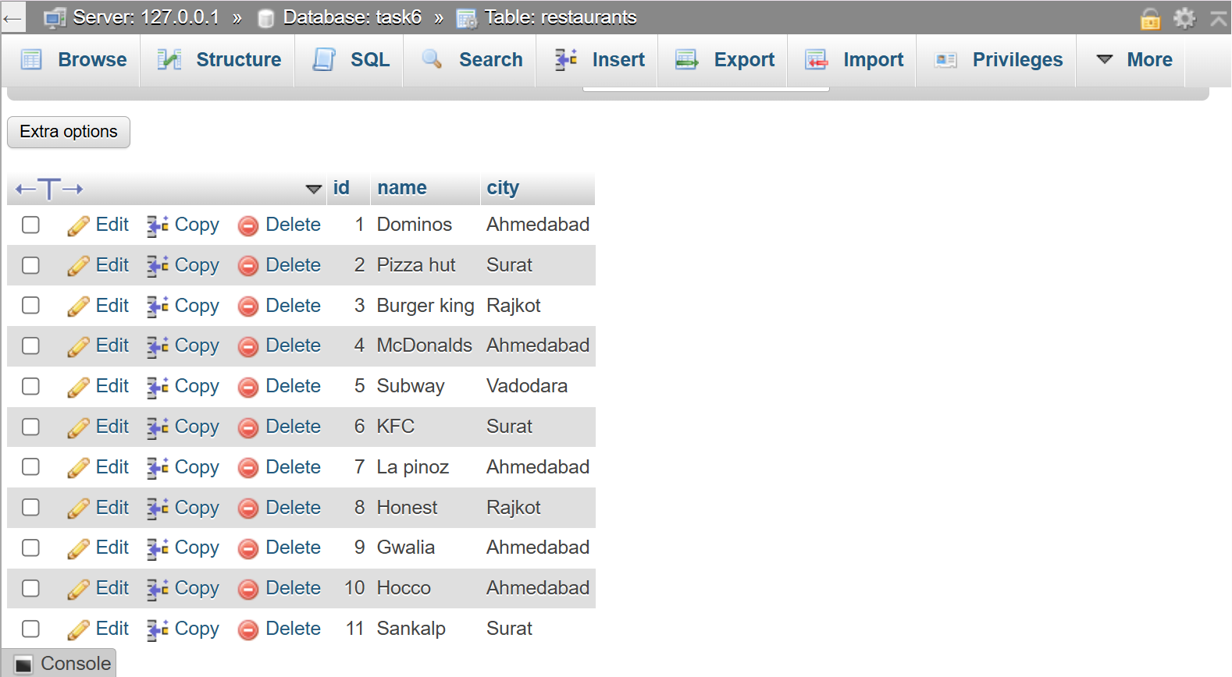
(10,'Hocco','Ahmedabad'), (11,'Sankalp','Surat');
QUESTION : 4

Write an SQL query to display the first 10 restaurants from a 'restaurants' table, sorted alphabetically by name, just like Zomato's A-Z listing.<br><br><em><strong>Hint:</strong> Use ORDER BY with LIMIT.</em> :

SELECT * FROM restaurants
ORDER BY name ASC
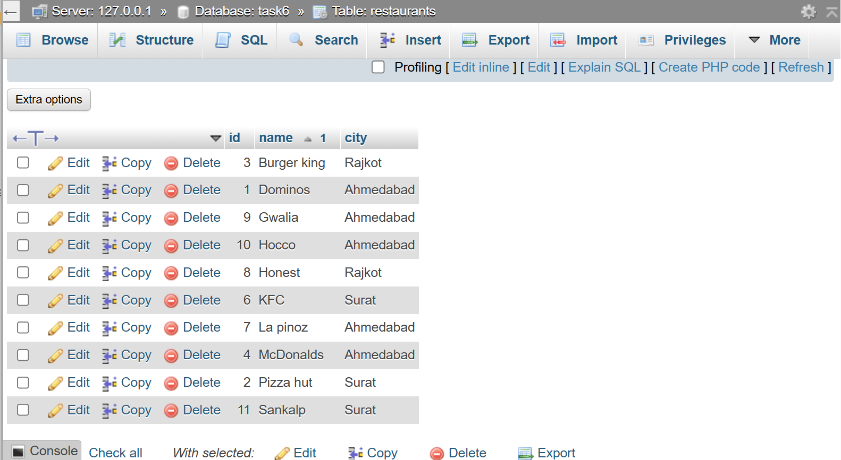
LIMIT 10;

TABLE 4:
CREATE TABLE songs (
id INT,
song_name VARCHAR(100),
artist VARCHAR(100),
play_count INT,
added_date DATE,
PRIMARY KEY(id)
);
INSERT :
INSERT INTO songs(id,song_name,artist,play_count,added_date)
VALUES (1,'Kesariya','Arijit singh',9500,'2026-07-01'),
(2,'Heeriye','Arijit singh',12000,'2026-07-05'),
(3,'Apna bana le','Arijit singh',12000,'2026-07-08'),
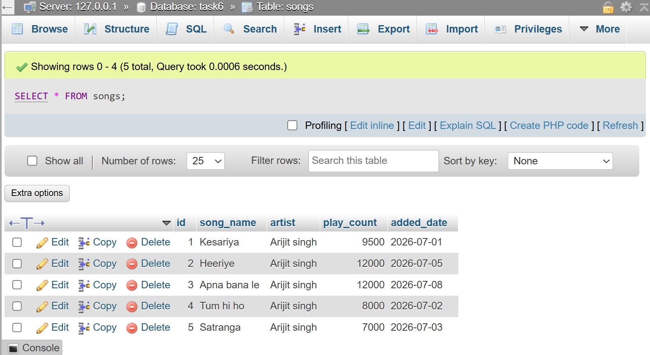
(4,'Tum hi ho','Arijit singh',8000,'2026-07-02'), (5,'Satranga','Arijit singh',7000,'2026-07-03');
QUESTION : 5

Suppose you want to display the top 3 trending songs from a 'songs' table based on play_count, but if two songs have the same play_count, the more recently added song should come first. Write the SQL query to achieve this.<br><br><em><strong>Hint:</strong> Use ORDER BY with multiple columns.</em> :

SELECT * FROM songs
ORDER BY play_count DESC,added_date DESC
LIMIT 3;
